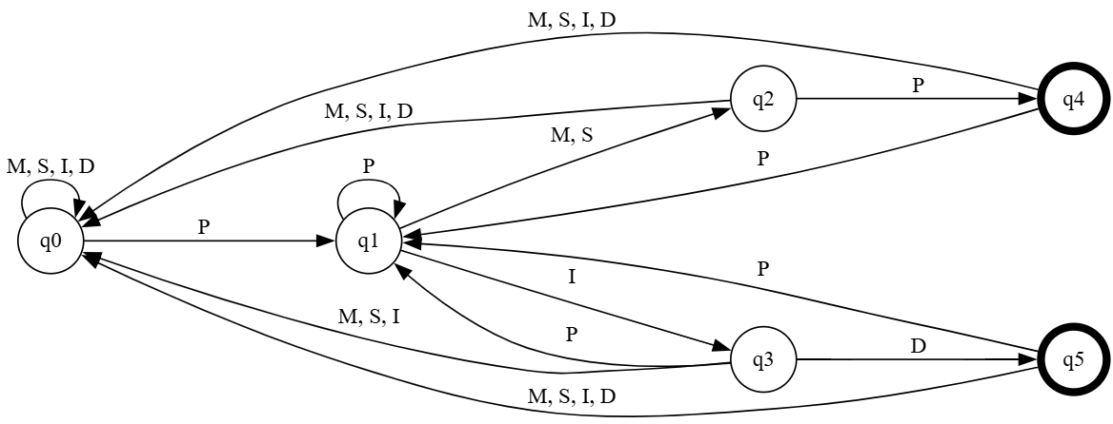

File specification

1. States: The first line contains a list of all states in the automaton.
2. Input Symbols: The second line lists all input symbols.
3. Start State: The third line specifies the start state.
4. Accept States: The fourth line enumerates the accept (final) states.
5. Transitions: Lines five through thirty-three define the state transitions. Each transition is represented on a separate line with three whitespace-separated elements:
6. Source State: The state from which the transition originates.
7. Input Symbol: The symbol that triggers the transition.
8. Destination State: The state to which the transition leads.

.

q0 q1 q2 q3 q4 q5

P M S I D

q0

q4 q5

q0 M q0

q0 S q0

q0 I q0

q0 D q0

q0 P q1

q1 P q1

q1 M q2

q1 S q2

q1 I q3

q2 P q4

q2 M q0  
q2 S q0

q2 I q0

q2 D q0

q3 D q5  
q3 M q0  
q3 S q0

q3 I q0

q3 P q1

q4 P q1

q4 M q0

q4 S q0

q4 I q0

q4 D q0

q5 P q1

q5 M q0

q5 S q0

q5 I q0

q5 D q0